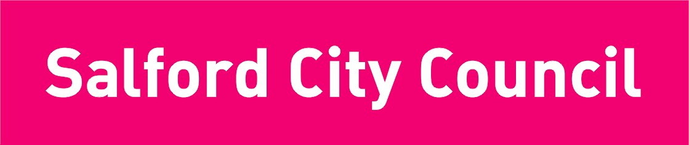

APPLICATION FORM FOR FREE TRANSPORT ASSISTANCE

IMPORTANT
This form should be completed and returned to: Transport Officer, SEN Team, Children’s Services Directorate, Burrows House, 10 Priestley Road, Wardley Industrial Estate, Worsley, M28 2LY.

Surname of pupil |  |  |  |  |  |  |  |  |  |  |  |  | First name of pupil
Surname of parent |  |  |  |  |  |  |  |  |  |  |  |  | First name of parent
Full address
 |  |  |  |  |  |  |  |  |  |  |  |  |  |  |  |  |  |  |  |  |  |  |  | Tel No
Date of birth |  |  |  |  |  |  |  |  |  | Year group
Name of school
Address of school
Academic year applying for: (tick one) |  |  |  |  |  |  |  |  |  |  |  | 2013-14
Does your child receive Free School Meals? |  |  |  |  |  |  |  |  |  |  |  |  |  |  |  |  |  |  |  | Yes |  |  |  |  |  |  |  |  |  |  | No
Are you in receipt of the highest working tax credit? |  |  |  |  |  |  |  |  |  |  |  |  |  |  |  |  |  |  |  |  | Yes |  |  |  |  |  |  |  |  |  | No
If yes, please provide a full copy of your current HM Revenue and Customs “tax credits award notice”)

Please provide your date of birth and National Insurance Number or NASS number
Parent’s DOB:
Parent’s National Insurance/NASS Number:
If you have recently moved, please state your previous address and date of move:
Please tick form of travel: |  |  |  |  |  |  |  | Bus |  |  |  |  |  |  | Cycle |  |  |  |  |  |  |  |  |  | Other |  |  |  |  |  |  | Please state:
Please complete the appropriate section below:
Total number of buses used each day
Route number/s
Signed |  |  |  |  |  |  |  |  | Print Name |  |  |  |  |  |  |  |  |  |  |  |  |  |  |  |  |  |  | Date
For Office Use Only |  |  |  |  |  |  | Over SWD |  |  |  |  |  |  | Walking distance to school
Entitled to Free School Meals |  |  |  |  |  |  |  |  | Yes |  |  |  |  |  |  | No
In receipt of maximum working Tax Credit |  |  |  |  |  |  |  |  |  |  |  |  | Yes |  |  |  |  |  |  |  |  | No

Home to School Transport
It is the responsibility of the parent(s) of a pupil to see that he/she attends school. However, the Council provides assistance with transport to school in circumstances detailed below, for pupils who live within the Salford Area. Pupils applying for free transport must live within the Salford boundary and be of statutory school age.

Pupils from Low Income Families
The Education and Inspections Act 2006, introduces free transport assistance for pupils from low income families. Those who qualify are pupils eligible for free school meals or from families in receipt of maximum working tax credit. Pupils meeting these criteria will receive reimbursement of bus fares providing that they are:-
- With effect from September 2007, primary pupils aged 8 years and under 11 years where they are attending their nearest suitable school more than two miles from their home.
- With effect from September 2008, all pupils who are aged 11-16 years attending one of their three nearest suitable schools (where this is over 2 miles to a maximum of 6 miles from their homes).
- With effect from September 2008, all pupils who are aged 11- 16 years to the nearest suitable school preferred on grounds of religion where they live more than two miles, but not more than 15 miles from that school.

Free Transport Provision for other pupils
Transport will be provided free of charge for pupils of primary and secondary school age travelling over the statutory walking distance to/from their nearest school. Pupils will be expected to use public transport.
Provision will be made for:
- Primary age pupils aged up to eight years travelling over two miles
- Primary age pupils aged over eight years and secondary age pupils travelling over three miles
- Provision means a single journey to school each morning and a return journey at the end of the school day
- Parents choosing a school further away from their home than another school that is appropriate to their child’s educational needs will be responsible for transport costs.

If you are unsure whether your child will be eligible for assistance with travel costs, please check with the Commissioning (SEN) Team on 0161-778-0410.

